Kubernetes

Need for Kubernetes
Containerization & Docker gained popularity pretty fast when it was introduced due to its features like a lightweight OS, portable environmentsand sharable isolated host kernel. However, they came with their own limitations, such as:
- Containers are only able to run on a single host
- Containers are ephemeral and thus need manual intervention for a restart
- Containers were not autoscalable
- Containers didn’t come with internal features like Load balancing, firewalls, and API gateways

Overall, there was no solid way to orchestrate these containers.

Introduction to Kubernetes
As a solution for the limitation of Containerization, Kubernetes was introduced. Kubernetes is a container orchestration platform that transforms the way applications are deployed, scaled, and managed in cloud environments.

Kubernetes supports resources that provide features like:
- Autoscaling
- Autohealing
- Support of multiple hosts using nodes
- Firewall, load-balancing, and API gateways

Architecture

A Kubernetes architecture consists of Clusters either under custom namespaces or default namespaces. A namespace helps to define a group under which a Kubernetes cluster runs.
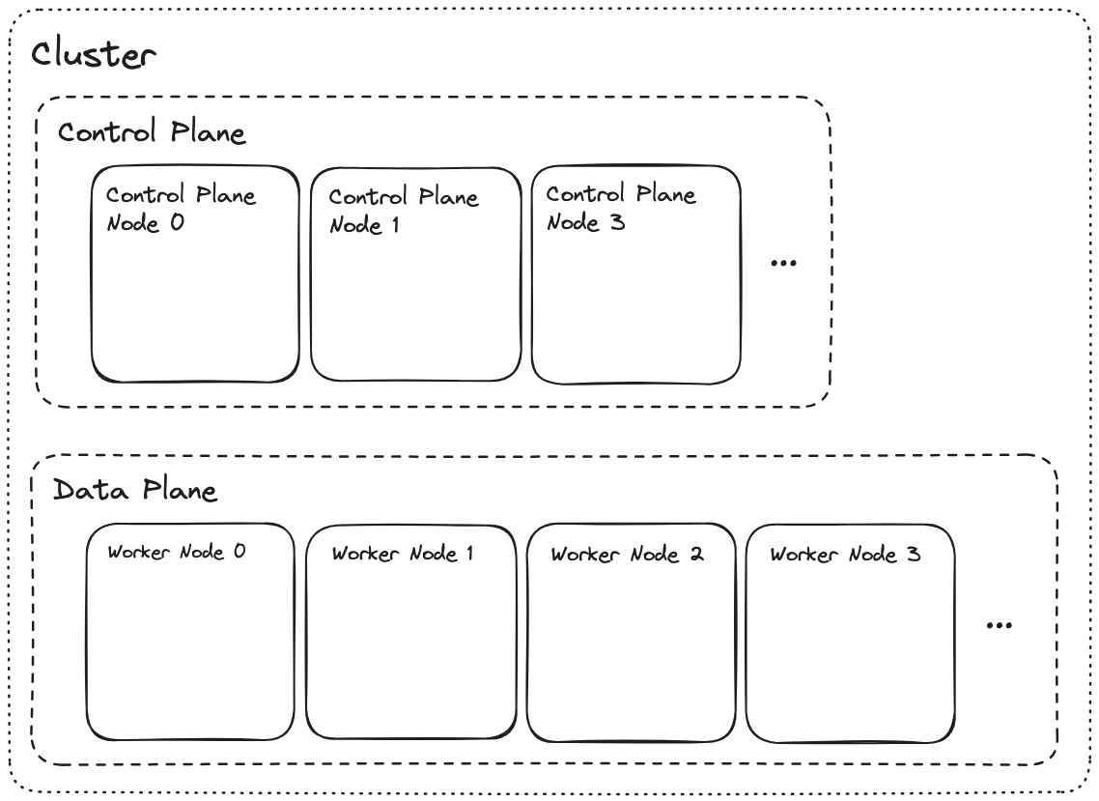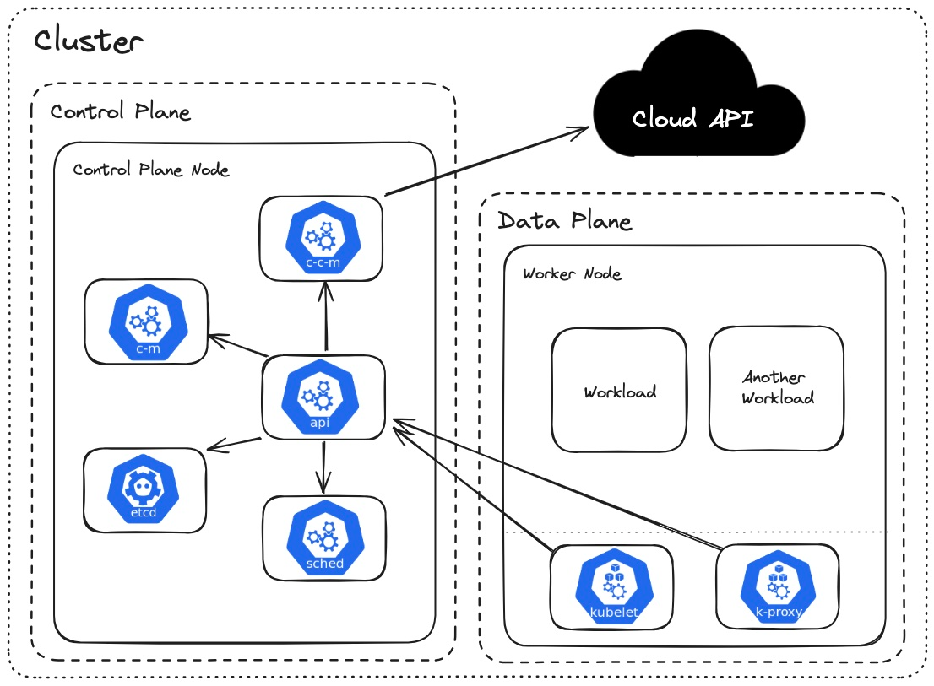
A Kubernetes cluster consists of two planes/nodes
- Control Plane (Master node): It manages the cluster and makes global decisions for the cluster
- Data Plane(Worker nodes): It runs the actual application workload under multiple worker nodes

Control Plane components:
- API server:
  - Central hub of Kubernetes APIs
  - Manages API requests that go in and out of the cluster
- Scheduler: Decides which node a pod should run on
- etcd: Key-value store that keeps cluster data and configs (source of truth)
- Controller manager:
  - Manages the desired cluster state
  - Also manages controllers like ReplicaSets
- Cloud Controller manager: Supports and helps to connect with the desired Cloud provider (AWS, Azure, etc.)

Data plane components:
- Kubelet:
  - Manages a pod lifecycle on each node
  - Reports back to the Master node
- Kube-proxy
  - Handles networking rules for the nodes
  - Manages load balancing through iptables
- Container-runtime
  - Executes the containers
  - Provides support to run containers on Docker shim, CRI-O, and containerd
Kubernetes Resources
To manage the applications and implement the features, Kubernetes provides support for multiple resources.

Pods
- A pod is the smallest deployable unit that wraps one or more containers
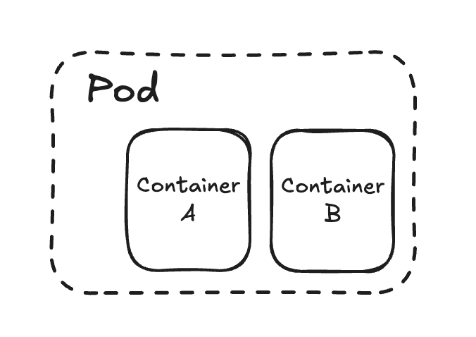
- Pods are managed over a cluster of nodes
- It enables fault isolation and resource distribution
- Pods are ephemeral
- Written in a YAML file with specifications of containers, ports, volumes, etc.

Deployments
- Deployments provide a high-level abstraction for managing pods using ReplicaSets
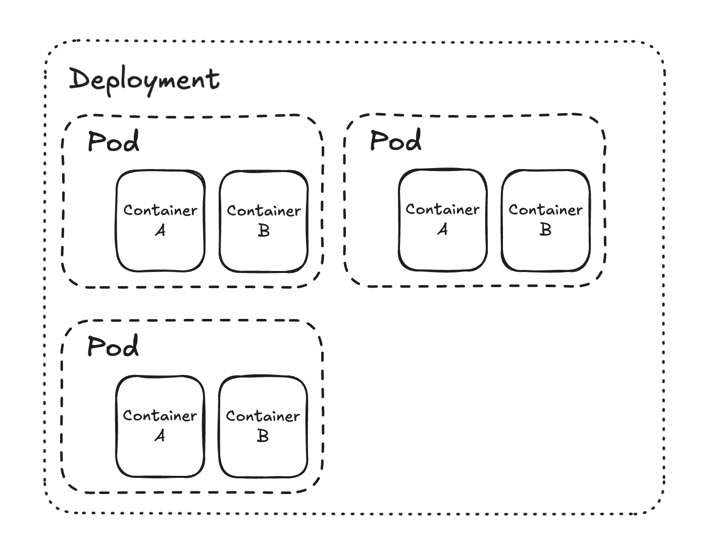
- ReplicaSets are copies of the pods running, each having the same state as the others
- It's this resource that provides Autohealing, Autoscaling, & zero downtime updates (updates pods without service interruption or termination)
- If a pod gets deleted, deployments add another pod automatically, thus countering the ephemeral state of pods

Services
- Services provide a stable IP address and DNS names to pods
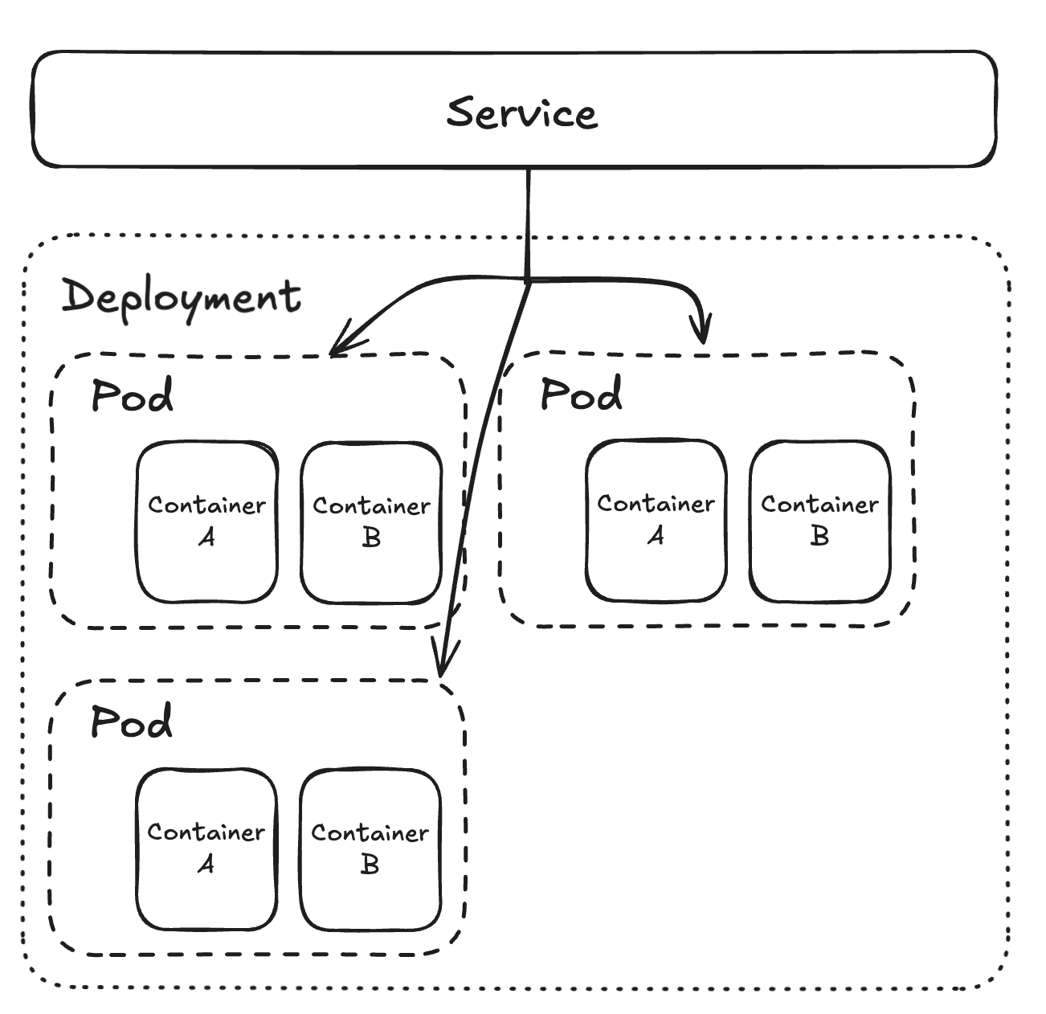
- The problem with deployments is that if one of the pods gets replaced, its IP address also changes, and thus, services help us to provide a label/selector to connect to the replaced pods without any network errors
- Services overall provide load-balancing service discovery (label/selectors) and external exposures (access to the pods in different ways)
- Externa exposure:
  - ClusterIP (default): Used for internal components of the cluster to communicate/access pods
  - NodePort (needs to be specified): Used for internal access with NodeIP. Used for testing and development
  - LoadBalancer (used by cloud provider): Exposes the pods over the internet using the cloud provider’s load balancer (example: Amazon Load Balancer (ALB))
StatefulSet
- A stateful set is a resource that manages stateful applications like databases.
- Provides guarantees about orders and the uniqueness of pods

Jobs
- Jobs are tasks that run one or more pods to completion of a task
- Example: Running an init_db.sql or migrations.sql script for installing the prerequisites of a database.

CronJobs
- This resource runs scheduled jobs at specified times or intervals
- Example: Running a task for users who are inactive for more than 6 months every month.

ConfigMaps
- Stores configuration data that can be consumed by the pods
- Example: Defining environment variables for a backend application

Secret
- Manages sensitive information like passwords, secret keys, and OAuth tokens
- Example: Stores a private key that can be used to decode a JSON token for Authentication

Ingress
- Problems with the service resources are that load-balancing isn’t flexible for changes. Example: Controlling the traffic based on URL path, Domain, TLS termination, etc., is not supported
- To counter these issues, an ingress controller provides
  - Path-based and host-based routing
  - TLS termination
  - Sticky sessions
  - IP whitelisting/blacklisting
  - Saves cost by only providing a single entry point for multiple services instead of using multiple cloud load balancers
  - Advanced traffic control, like rate limiting, load balancing strategies, etc
- Example: an NGINX ingress controller provides features like path-based routing(separate for front-end & backend), reverse-proxy, rate-limiting, API-gateway, etc
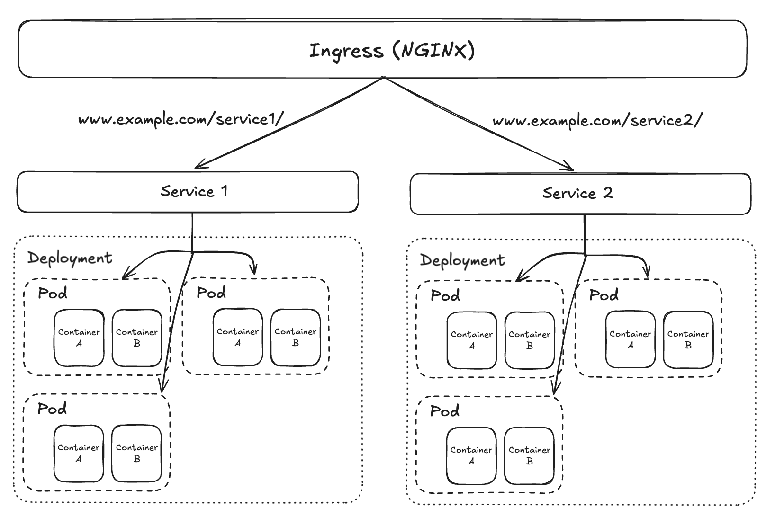

RBAC (Role-based Access Control)
- RBAC is a resource that secures clusters by defining
  - Users and groups (externally using LDAP, IAM, OAuth)
  - Service accounts (for pods, cluster controllers, etc)
  - Roles and cluster roles (within namespaces/cluster)
  - Rolebinding & ClusterRolebindings (roles to users mapping)
- RBAC ensures least privilege access and protects critical resources like ConfigMaps and Secrets from unauthorized access
- Admins can define roles for dev, QA, ops, etc

